Experiment worksheet

1.1 Science is the study of the natural and physical world

Pages 2–3 and 170

Challenge 1.1: Sideways Ping Pong

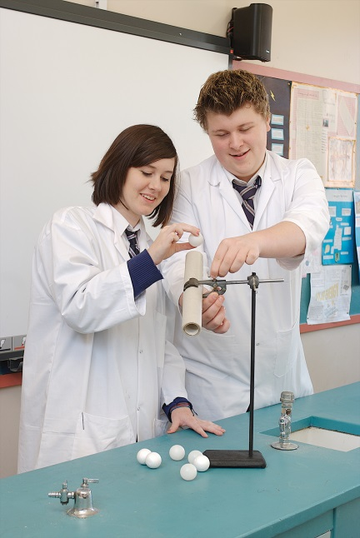**What you need**:

ping pong ball, measuring tape or ruler, cardboard cylinder

What to do:

1 Working in pairs, drop a ping pong ball from a height of 1.5 metres above the ground. Do not throw or flick it.

2 Measure how far the ball travels sideways after it bounces.

What if?

• What if you change the colour of the ball?

• What if you change the type of floor covering?

• What if you drill holes in the ball?

• What if you roll the ball down a tube?

• What if you spin the ball?

• What if you vary the height from which the ping pong ball is dropped?

Experiment worksheet

1.2 Scientists use specialised equipment

Pages 4–5 and 171

Skills Lab 1.2: Drawing scientific diagrams

Station 1

What you need:

five boxes from your teacher (each containing five different pieces of equipment), grey pencil, ruler, piece of plain A4 paper

What to do:

1 Share a box with a partner. Without using this textbook, write down the name of each piece of equipment in the box and draw a scientific diagram of each in pencil. When finished, return the box to the teacher and collect a different one.

2 Check your answers and diagrams (and spelling) for the pieces of equipment from Figures 1.9 and 1.10 on pages 4 and 5. Correct any mistakes.

3 Look at your list of equipment. On a sheet of plain paper, divide the list into groups according to use. For example, you might put all pouring equipment together, or all heating equipment or all safety equipment. Decide on categories first and then allocate the equipment.

Station 2

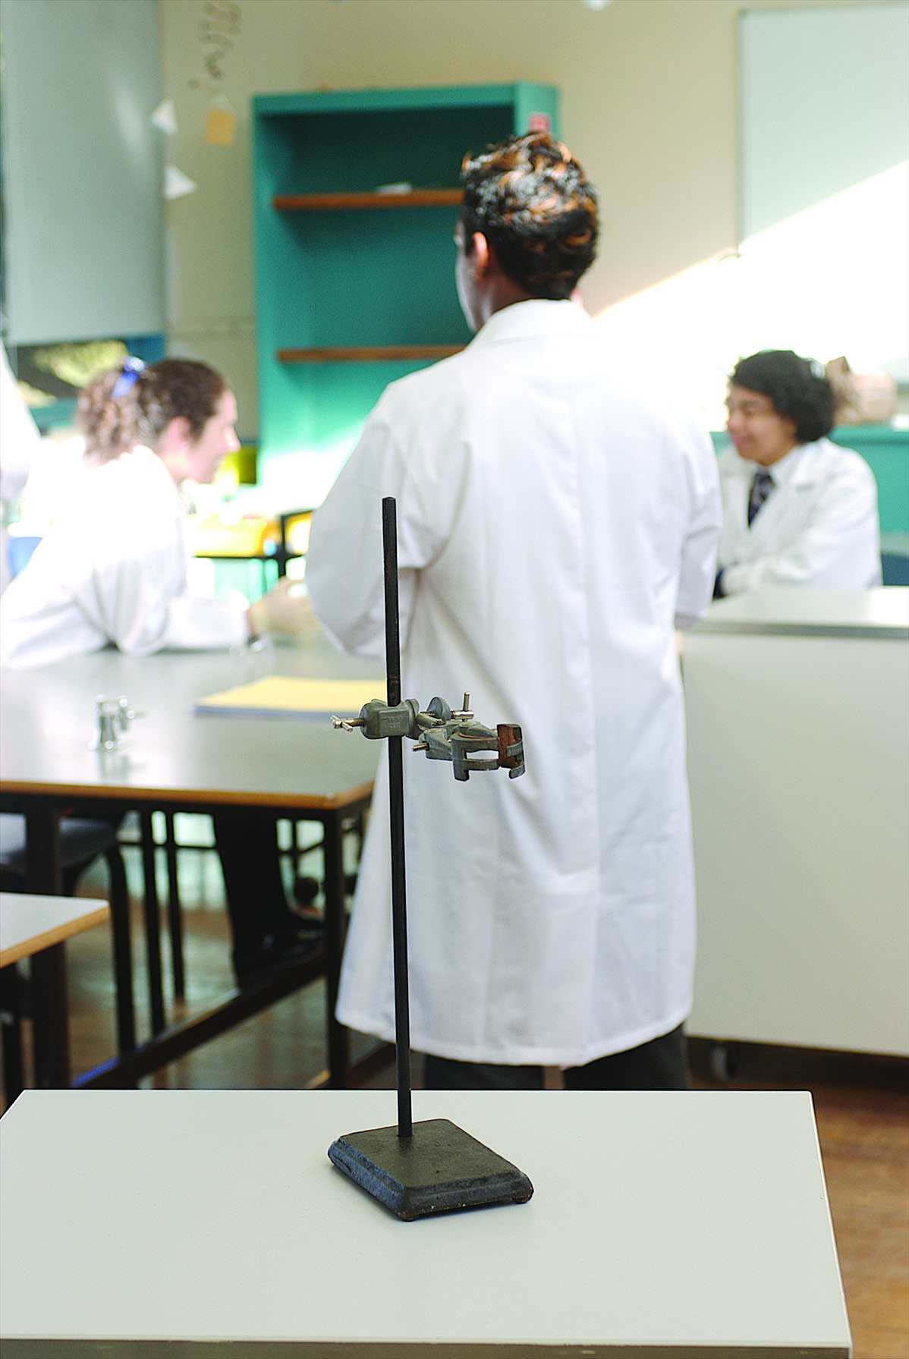What you need:

large flask, retort stand, boss head, clamp, funnel, small beaker

What to do:

1 Set up the stand with the boss head and clamp, placing the boss head approximately two-thirds of the way up the stand, as shown in the image to the right.

2 Carefully place the flask neck into the clamp and tighten the clamp so the flask is secure. (The flask should be approximately 10 cm above the bench, not resting on it.)

3 How many beakers of water do you think will fill the flask? Write down your prediction (your best guess of what will happen).

4 Fill the beaker with water. Use the funnel to transfer the water into the flask.

• How many full beakers of water did you need to completely fill the flask?

• Was your prediction correct? \_\_\_\_\_\_\_\_\_\_\_\_\_\_\_\_\_\_\_\_\_\_\_\_\_\_\_\_\_\_\_\_\_\_\_\_\_\_\_\_\_\_\_\_\_\_\_\_\_\_\_\_

5 Draw a scientific diagram of what you have set up, labelling all equipment.

6 Take the apparatus apart and place each piece of equipment in its appropriate cupboard.

Questions

1 Which piece of equipment was the most difficult to draw?

2 Which did you find the easiest to draw?

3 Name up to five pieces of equipment you had not seen before and list their uses in a laboratory.

4 Name two pieces of equipment that can be used for:

a holding things: 1\_\_\_\_\_\_\_\_\_\_\_\_\_\_\_\_\_\_\_\_\_\_\_\_2\_\_\_\_\_\_\_\_\_\_\_\_\_\_\_\_\_\_\_\_\_\_\_\_\_\_\_\_\_\_\_\_\_\_\_

b mixing chemicals: 1\_\_\_\_\_\_\_\_\_\_\_\_\_\_\_\_\_\_\_\_\_\_2\_\_\_\_\_\_\_\_\_\_\_\_\_\_\_\_\_\_\_\_\_\_\_\_\_\_\_\_\_\_\_\_\_\_\_\_

c pouring: 1\_\_\_\_\_\_\_\_\_\_\_\_\_\_\_\_\_\_\_\_\_\_\_\_\_\_\_\_\_\_2\_\_\_\_\_\_\_\_\_\_\_\_\_\_\_\_\_\_\_\_\_\_\_\_\_\_\_\_\_\_\_\_\_\_\_\_

5 Where in your laboratory do you find:

a test tubes? \_\_\_\_\_\_\_\_\_\_\_\_\_\_\_\_\_\_\_\_\_\_\_\_\_\_\_\_\_\_\_\_\_\_\_\_\_\_\_\_\_\_\_\_\_\_\_\_\_\_\_\_\_\_\_\_\_\_\_\_\_\_\_\_\_\_

b Bunsen burners? \_\_\_\_\_\_\_\_\_\_\_\_\_\_\_\_\_\_\_\_\_\_\_\_\_\_\_\_\_\_\_\_\_\_\_\_\_\_\_\_\_\_\_\_\_\_\_\_\_\_\_\_\_\_\_\_\_\_\_\_\_\_

c tongs? \_\_\_\_\_\_\_\_\_\_\_\_\_\_\_\_\_\_\_\_\_\_\_\_\_\_\_\_\_\_\_\_\_\_\_\_\_\_\_\_\_\_\_\_\_\_\_\_\_\_\_\_\_\_\_\_\_\_\_\_\_\_\_\_\_\_\_\_\_\_

d retort stands? \_\_\_\_\_\_\_\_\_\_\_\_\_\_\_\_\_\_\_\_\_\_\_\_\_\_\_\_\_\_\_\_\_\_\_\_\_\_\_\_\_\_\_\_\_\_\_\_\_\_\_\_\_\_\_\_\_\_\_\_\_\_\_\_

e test tube racks? \_\_\_\_\_\_\_\_\_\_\_\_\_\_\_\_\_\_\_\_\_\_\_\_\_\_\_\_\_\_\_\_\_\_\_\_\_\_\_\_\_\_\_\_\_\_\_\_\_\_\_\_\_\_\_\_\_\_\_\_\_\_\_

f heating mats? \_\_\_\_\_\_\_\_\_\_\_\_\_\_\_\_\_\_\_\_\_\_\_\_\_\_\_\_\_\_\_\_\_\_\_\_\_\_\_\_\_\_\_\_\_\_\_\_\_\_\_\_\_\_\_\_\_\_\_\_\_\_\_\_

g a rubbish bin? \_\_\_\_\_\_\_\_\_\_\_\_\_\_\_\_\_\_\_\_\_\_\_\_\_\_\_\_\_\_\_\_\_\_\_\_\_\_\_\_\_\_\_\_\_\_\_\_\_\_\_\_\_\_\_\_\_\_\_\_\_\_\_\_

h beakers? \_\_\_\_\_\_\_\_\_\_\_\_\_\_\_\_\_\_\_\_\_\_\_\_\_\_\_\_\_\_\_\_\_\_\_\_\_\_\_\_\_\_\_\_\_\_\_\_\_\_\_\_\_\_\_\_\_\_\_\_\_\_\_\_\_\_\_\_

Experiment worksheet

1.4 Scientists use observation and inference to answer questions

Pages 8–9 and 172

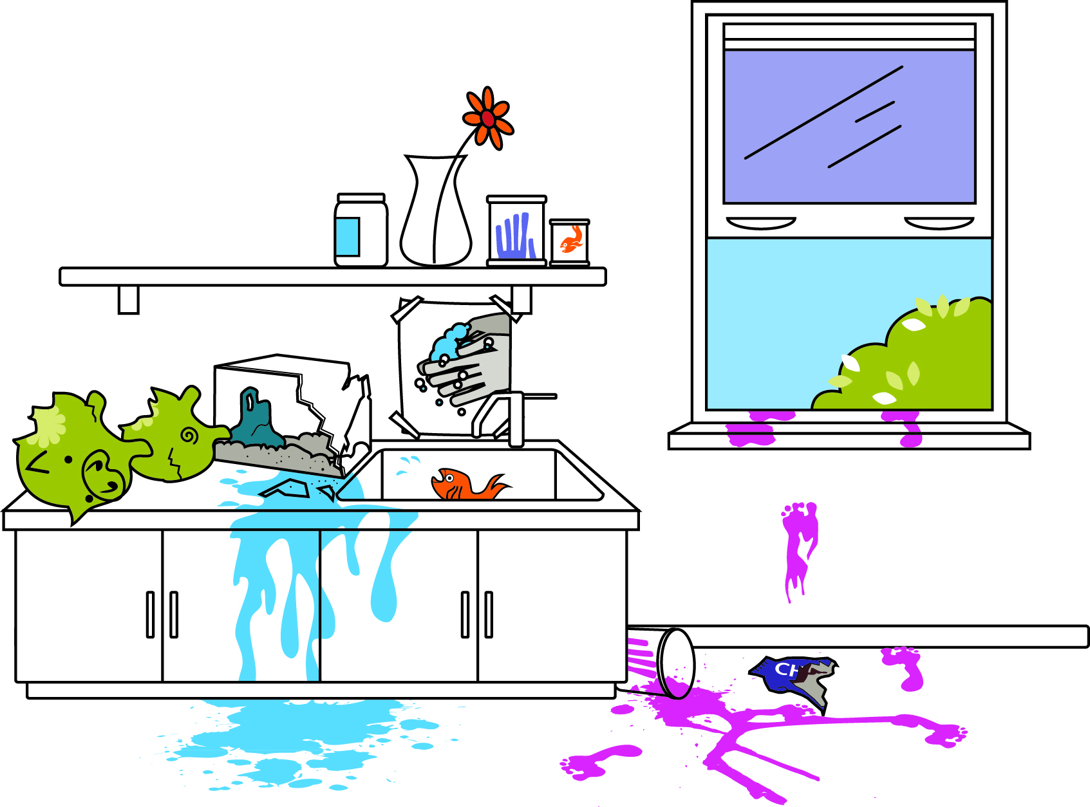Skills Lab 1.4: Observation versus inference

How good are you at making observations? Do you confuse observations with inferences? There are many things you can observe.

1 Examine the drawing of a crime scene. In the table provided, write six observations from the crime scene.

2 Write down three inferences you can make from your observations.

|  |  |
| --- | --- |
| Observations | Inferences |
|  |  |

Experiment worksheet

1.5 Science relies on measuring with accuracy

Pages 10–13 and 172

Skills Lab 1.5: Measuring mass and volume

What you need:

a variety of soft drinks, flavoured milk, fruit juices, bottled water, sugar, scales, measuring cylinder, beakers

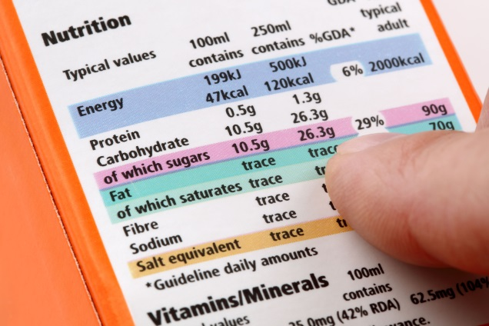What to do:

1 On the sides of each container you will find a nutrition panel showing the volume of one standard serve and the amount of sugar in each drink. An example is shown in the image to the right.

2 Using the scales, measure out the mass of sugar in each serve of drink in a beaker.

3 In another beaker, carefully measure out the volume of a single serve of each drink.

4 Using the table provided record the name of each drink, the sugar content per serve for each drink, how many serves of drink were in each container and how much sugar there was in a whole container.

|  |  |  |  |
| --- | --- | --- | --- |
| Drink | Sugar content per serve | How many serves of drink per container | How much sugar in the whole container |
|  |  |  |  |

Questions

1 Which drink had the most sugar?

2 Which drink had the most serves in a single container?

3 Which drink had the most sugar in a whole container?

4 Was there any volume or sugar content that surprised you?

Experiment worksheet

1.6 A Bunsen burner is an essential piece of laboratory equipment

Pages 14-15

Skills lab 1.6A: Lighting a Bunsen burner

**REMEMBER** to keep your hand below the flame.

What you need:

Bunsen burner, heating mat, matches

**CAUTION:** Keep your notebook and other materials well away from the Bunsen burner (on a nearby bench or further up the bench).

What to do:

Light the Bunsen burner using the following five steps:

|  |  |  |
| --- | --- | --- |
| 1 Place the Bunsen burner on the heating mat.  C:\Users\berglunde\AppData\Local\Microsoft\Windows\Temporary Internet Files\Content.Word\01078_SHO_BS7-r.jpg | 2 Connect the rubber hosing firmly to the gas tap.  C:\Users\berglunde\AppData\Local\Microsoft\Windows\Temporary Internet Files\Content.Word\01079_SHO_BS7-r.jpg | 3 Close the air hole by turning the collar.    C:\Users\berglunde\AppData\Local\Microsoft\Windows\Temporary Internet Files\Content.Word\01080_SHO_BS7-r.jpg |
| 4 Light a match and place it above the barrel, with your hand below the flame.  C:\Users\berglunde\AppData\Local\Microsoft\Windows\Temporary Internet Files\Content.Word\01081_SHO_BS7-r.jpg | 5 Open the gas tap fully.  C:\Users\berglunde\AppData\Local\Microsoft\Windows\Temporary Internet Files\Content.Word\01082_SHO_BS7-r.jpg | 6 After you have followed these steps the Bunsen burner will have a yellow (safety) flame.  C:\Users\berglunde\AppData\Local\Microsoft\Windows\Temporary Internet Files\Content.Word\01083_SHO_BS7-r.jpg |

Experiment worksheet

1.6 A Bunsen burner is an essential piece of laboratory equipment

Page 15

Skills lab 1.6B: Using your Bunsen burner

What you need:

**CAUTION:** The porcelain you heat will remain very hot for a long time. Do not pick it up with your fingers; use tongs

Bunsen burner, heating mat, matches, notebook, coloured pencils, grey pencil, metal tongs, 2 pieces of white ceramic or porcelain.

What to do:

Wear safety goggles and a lab coat.

1 Follow steps 1-5 from Skills lab 1.6a: Lighting a Bunsen burner.

2 Change the flame to a blue flame by opening the air hole on the collar.

3 Write down and draw what happens to the flame when the hole is closed, half open and full open.

4 Close the collar so that a yellow flame is produced.

5 Using the tongs, hold a piece of porcelain in the top of the yellow place for a minute. Place the hot porcelain on the heating mat when you have finished. Describe what happens to the porcelain and draw it.

6 Hold the other piece of porcelain with the tongs. Change the flame to blue and heat the porcelain for 1 minute. Describe what happens to this piece of porcelain and draw it.

• Why do you think the yellow flame is called the safety flame? Give at least two reasons.

• Which flame is noisier: blue or yellow? Why is this helpful to know?

• Which flame leaves a sooty carbon black deposit on whatever object it heats?

• Which flame is the ‘clean’ flame for heating?

• Give reasons for using a blue flame for heating in an experiment.

Experiment worksheet

1.8 Graphs and tables are used to show results

Pages 18–21 and 173

Skills Lab 1.6: Heating water

What you need:

beaker, water, thermometer, retort stand, boss head, clamp, tripod, gauze mat, safety mat, stopwatch

What to do:

1 Set up the equipment as shown below.

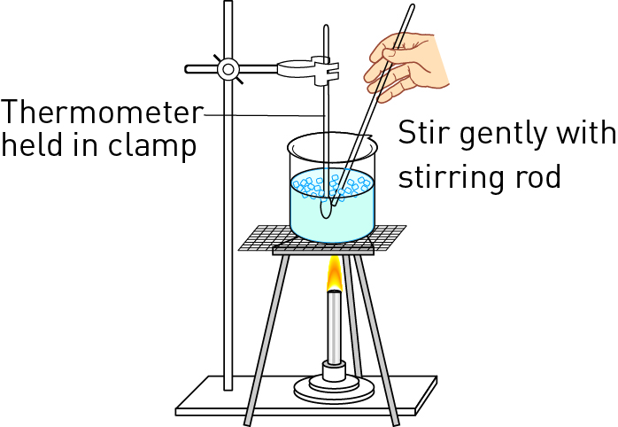

2 Draw a scientific diagram of the equipment.

|  |
| --- |
|  |

3 Measure the starting temperature of the water. Write this in the table provided for 0 minutes.

|  |  |
| --- | --- |
| Time (minutes) | Temperature (°C) |
|  |  |
|  |  |
|  |  |
|  |  |
|  |  |
|  |  |
|  |  |
|  |  |
|  |  |
|  |  |
|  |  |
|  |  |
|  |  |

4 Safely light the Bunsen burner and then open the collar to get a blue flame.

5 Heat the water over the Bunsen burner, recording the temperature of the water every minute for a total of 12 minutes.

Inquiry: What if another substance is added to the water?

Choose one of the inquiry questions below.

• What if sugar was added to the water?

• What if salt was added to the water?

Answer the following questions with regard to your inquiry question.

• Write a hypothesis for your inquiry.

• What *independent* variable will you change from the first method?

• What *dependent* variable will you measure and/or observe?

• What variables will you need to control to ensure a fair test? How will you control them?

• Test your hypothesis.

• Draw an appropriate graph for your data.

|  |
| --- |
|  |

Questions

1 What type of data have you collected?

2 What type of graph should you draw for this type of data?

3 Does your graph support your hypothesis? Explain.

4 Was your experiment a fair test? Explain why or why not.